ve

**Importer User Manual v 2.0**

* **Central Equipment Identity Register Importer Portal**

Document Change History

|  |  |  |  |
| --- | --- | --- | --- |
| Version | Change Type | Description | Date |
| Draft |  | Submitted for internal review | February 2020 |
| Version 2.0 |  | Multiple System Admin, Configurable Notifications, Only IMEI supported, Filter and sorting, Field Validations, History of the request, Address management | June 2021 |

Contents

1 Overview 1

1.1 Scope 1

1.2 Acronyms & Abbreviations 1

1.3 Conventions 1

2 Importer Operations 2

2.1 Application Overview 2

2.2 Logging into the Application 3

2.3 Application User Interface 10

2.3.1 Dashboard 12

2.4 Manage Consignments 18

2.5 Edit Consignments 23

2.6 Filter Consignments 24

2.7 Export Consignments 25

2.8 Stock Management 27

2.9 Edit Stock 31

2.10 Filter Stock 32

2.11 Export Stock 34

2.12 Grievance Management 35

2.13 Filter Grievances 38

2.14 Export Grievances 40

2.15 Type Approval Management 41

2.16 Edit Type Approved Devices 45

2.17 Filter Type Approved Devices 46

2.18 Export Type Approved Devices 48

Figures

Figure 1: CEIR Home Page 3

Figure 2: Importer Registration 4

Figure 3: Verify OTP 6

Figure 4: Enter OTP 6

Figure 5: Login 7

Figure 6: Home Page 8

Figure 7: Forgot Password 8

Figure 8: Set New Password 9

Figure 9: Home Page 10

Figure 10: Edit Information 11

Figure 11: Change Password 11

Figure 12: Manage Account 12

Figure 13: Home Page 13

Figure 14: Consignment 13

Figure 15: Stock Management 14

Figure 16: Grievance Management 15

Figure 17: Manage Type-Approved 16

Figure 18: Home Page 16

Figure 19: Home Page 19

Figure 20: Consignment 19

Figure 21: Register Consignment 19

Figure 22: Consignment 23

Figure 23: Edit Consignment 24

Figure 24: Consignment 24

Figure 25: Consignment 25

Figure 26: Sort Consignment 26

Figure 27: Export Consignment 26

Figure 28: Open or Save Exported Consignment File 26

Figure 29: Exported Consignments 27

Figure 30: Home Page 27

Figure 31: Role Type 28

Figure 32: Stock Management 28

Figure 33: Upload Stock 28

Figure 34: Stock Management 30

Figure 35: Stock Management 32

Figure 36: Edit Stock 32

Figure 37: Stock Management 33

Figure 38: Stock Management 33

Figure 39: Stock Management 34

Figure 40: Stock Management 34

Figure 41: Open or Save Exported Stock File 34

Figure 42: Exported Stock 35

Figure 43: Home Page 36

Figure 44: Grievance Management 36

Figure 45: Create Grievance 36

Figure 46: Grievance Management 37

Figure 47: Filter Grievances 39

Figure 48: Filtered Grievances 39

Figure 49: Grievance Management 40

Figure 50: Grievance Management 40

Figure 51: Open or Save Exported Grievance File 41

Figure 49: Exported Grievances 41

Figure 50: Home Page 42

Figure 51: Manage Type-Approved 42

Figure 52: Type-Approved Devices 42

Figure 53: Manage Type-Approved 43

Figure 54: Manage Type-Approved 45

Figure 55: Update Report Type-Approve Devices 46

Figure 56: Filter Type Approval Requests 46

Figure 57: Filtered Type Approval Requests 47

Figure 58: Export Type Approval Requests 48

Figure 59: Open or Save Exported File 49

Figure 60: Exported Type Approval Requests 49

# Overview

## Scope

The objective of this manual is to help importers use the CEIR (Central Equipment Identity Register) application to register consignments, manage type approval requests, and report grievances.

## Acronyms & Abbreviations

| **Acronym** | **Full Form** |
| --- | --- |
| CEIR | Central Equipment Identity Register |
| IMEI | International Mobile Equipment Identity |
| PDA | Personal Digital Assistant |
| TAC | Type Allocation Code |
| TRC | Telecommunication Regulator of Cambodia |

## Conventions

| **Information** | **Convention** |
| --- | --- |
| UI elements  (such as names of windows, buttons, and fields) | Bold |
| References  (such as names of files, sections, paths, and  parameters) | *Italics* |
| **\*** | Indicates a mandatory field or column |

# Importer Operations

## Application Overview

The CEIR (Central Equipment Identity Register) Importer Portal application is used to register SIM-based devices that are imported in Cambodia. Registration of all the imported devices ensures proper tax is paid to the customs before the devices are made available for sale in the market. In addition, registration helps in tracking device movement and prevents their misuse or theft. The application also enables importers to upload the type approval requests for of the devices. This is required for clearance by customs.

After purchasing devices from suppliers, the importers register necessary information about the devices and suppliers in the system. The registered information is reviewed and approved by the CEIR Admin and subsequently shared with the customs for clearance. When the physical consignment of the devices is received at the customs premises, the importers go and pay the required tax and collect the consignment. After the taxes are paid, the consignment is made available to distributors and retailers for sale in the market.

Importers perform the following tasks:

* Register imported device consignments
* Upload stock (if the importer is also a distributor or retailer else this is done by the distributors and retailers)
* Upload type approval certificates for the imported devices
* Report grievances

## Logging into the Application

Before login, the importer must register in the application.

To register:

1. Enter the CEIR Home Portal URL in the browser address bar. This opens the CEIR Home Portal page.

Figure 1: CEIR Home Page

1. Select **Importer** from the **Registration** list.

The **Importer Registration** page appears. The importer needs to fill in the following information.

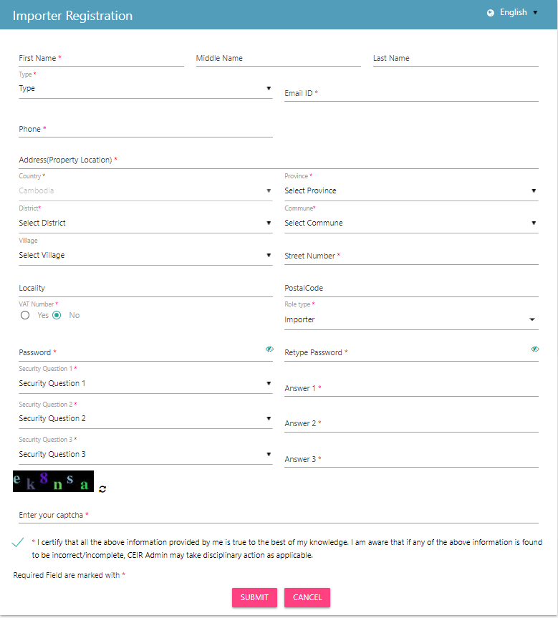

Figure 2: Importer Registration

1. **\*First Name**: Enter the first name.
2. **Middle Name**: Enter the middle name (if any).
3. **Last Name**: Enter the last name.
4. **\*Type**: Select the type of importer (Individual, Organization). If an individual, enter the national ID. If an organization, enter the organization name.
   1. **\*National ID/Passport Number**.: Enter the national ID (NID). This field appears when the importer selects **Individual** in **Type**.
   2. **\*Upload Nationality Information**: Click **Select File** to upload a scanned copy of the NID document.
   3. **Company Name**: Enter the organization name, if the importer is a company. This field appears if the importer selects **Organization** in **Type**.
5. **\*Email**: Enter the mail ID. This mail ID would be used for communication.
6. **\*Phone**: Enter the contact number. This number would be used to send notifications.
7. **\*Address**: Enter the importer’s address:
   1. **\***Street Number
   2. Village
   3. Locality
   4. **\***District
   5. **\***Commune
   6. **\***Province
   7. **\***Country
8. **\*Role**: Select the importer’s role from the list (Importer, Distributer, Retailer). An importer can also be a distributer and/or retailer. If an importer has multiple roles, select the different role types.
9. **\*VAT Registration**: Select whether VAT registration is done. If **Yes**, enter the following:
   1. **VAT Number:** Enter the VAT number.
   2. **VAT File**: Click **Select File** to upload the VAT file.

This field is mandatory if **Type** is **Company**.

1. **\*Password**: Enter a login password. This is the password that would be used to log into the CEIR Importer Portal application.
2. **\*Confirm Password**: Re-enter the password for confirmation.
3. **\***Select three security questions and enter an answer for each question. This is required by the system when the importer forgets the password. In such a situation, the system requires identification to authenticate the importer. These security questions are used for authentication of the importer.
4. **\***Enter the captcha shown on the page. This is required to prove that the importer is not a robot.
5. **\***Select the declaration check box.
6. Click **SUBMIT**.

An OTP is sent to the importer’s mail ID and contact number.

Figure 3: Verify OTP

The importer is prompted to enter both the OTPs in the page for verification.

Figure 4: Enter OTP

Enter the two OTPs and click **Done**.

If the two OTPs match, the following message appears. If the OTPs do not match, click **Resend OTP**. The two OTPs are resent, one to the contact number and the other to the mail account.

After the OTPs are verified successfully, the registration request is sent to the CEIR Admin. The approval turnaround time is 2-3 days. After approval from the CEIR Admin, a mail containing the importer’s registration ID is sent to the importer’s mail account. This registration ID is a unique automatically generated ID. This ID is the login username for access to the CEIR Importer Portal application.

To start using the application, log into the application.

To login:

1. Open the browser and enter the CEIR Importer Portal URL in the address bar. The login screen appears.

Figure 5: Login

On the top right corner of the login screen is the **Language** option. The application supports two languages: **English** and **Khmer**. On selecting a given language, all the field and column labels in the application appear in the selected language. All user inputs are, however, in English.

1. Next, enter the assigned login username and password.

Username is the registration ID that is sent on mail to the importer after successful registration in the system. The registration ID is a unique ID that is automatically generated by the system. The login password is the password that the importer enters in the registration page. Refer to during *Figure 2: Importer Registration*.

1. Enter the captcha.
2. Click **LOGIN**.

If the login and password are incorrect or the captcha is not correct, an error message appears, and you are prompted to re-enter the login details.

On entering correct information, the application Home page appears.

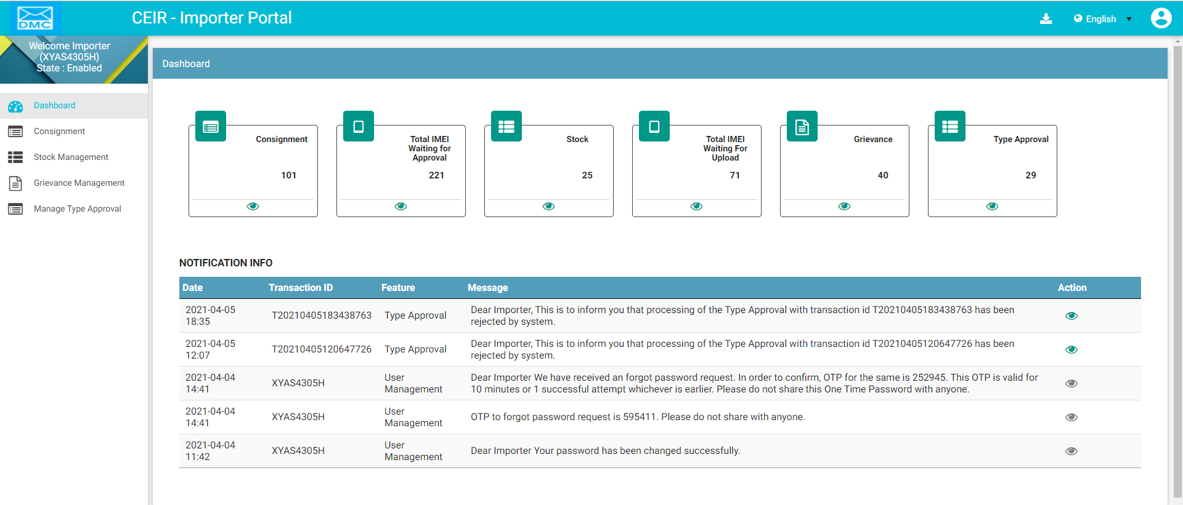

Figure 6: Home Page

If the importer forgets the assigned password, click the **Forgot Password** link on the **Login** page. The **Forgot Password** page appears.

Figure 7: Forgot Password

1. Enter the login username.
2. Select a security question from the list. Select any one of the security questions that were selected during registration.
3. Enter the answer to the selected security question. This should match the answer given at the time of registration.
4. Click **SUBMIT**.

The **Set New Password** page appears.

Figure 8: Set New Password

1. Enter a new password. Click  to see the password characters being entered. Click on it again to hide the password characters. This works like a toggle key.
2. Re-enter the password.
3. Click **Save**.

## Application User Interface

On logging into the application successfully, the CEIR Importer Portal Home page appears.



Figure 9: Home Page

The Home page has all the feature menus on the left panel.

The center of the page is the Dashboard.

The top right corner of the screen displays the following menu options:

* **Download**: Click to download this user manual.
* **English**: Select **English** or **Khmer**. All the field and column labels appear in the selected language. User inputs are, however, in English.

* A close up of a logo

  Description automatically generated(**User profile**): Click on it to see the following menu:

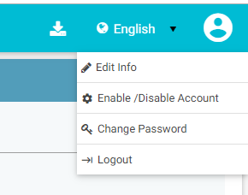

*  (**Edit Info**): Click on it to modify the registered information. The **Edit Information** page opens.

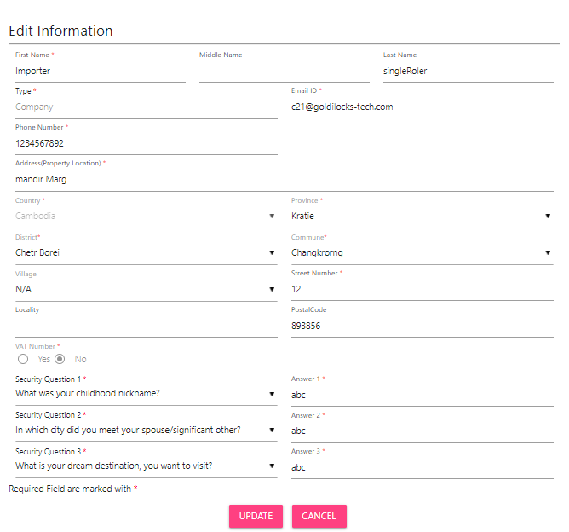

Figure 10: Edit Information

1. Make the required changes.
2. Click **Update** to save the changes. OTP is sent to the user in case contact number or email id is changed. In all other cases, user is prompted to enter the password for confirmation of edit profile.

*  (**Change Password**): Click on it change the login password.

Figure 11: Change Password

1. **Old Password**: Enter the existing password. Click  to see the password characters being entered. Click on it again to hide the password characters. This works like a toggle key.
2. **New Password**: Enter a new password.
3. **Confirm Password**: Re-enter the new password to confirm the password.
4. Click **SUBMIT**.

*  (**Enable/Disable Account**): Importers can deactivate their account or disable/enable their account.
  + Deactivating an account means deleting the importer’s account. Once the importer’s account is deleted, the importer can raise a grievance to reactivate it when required. The grievance is sent to the CEIR Admin who reactivates the account. After reactivation, the importer can use the same login username and password to log into the application.
  + When the account is disabled, importers can only view information and not add or modify information in the application. After the account is disabled, the importer can enable it using the same menu.

Figure 12: Manage Account

1. Select **Deactivate** or **Disable**.
2. Click **SUBMIT**.

**Dashboard**

The Dashboard provides a quick display and access to the following information:

* Consignments
* Stock
* Type Approved Requests
* Grievances



Figure 13: Home Page

**Consignments**

The **Consignment** box displays the total number of consignments waiting to be cleared by the customs.

Click  (**View**) to go to the **Consignment** dashboard. Refer to *Consignment Management* for more information.

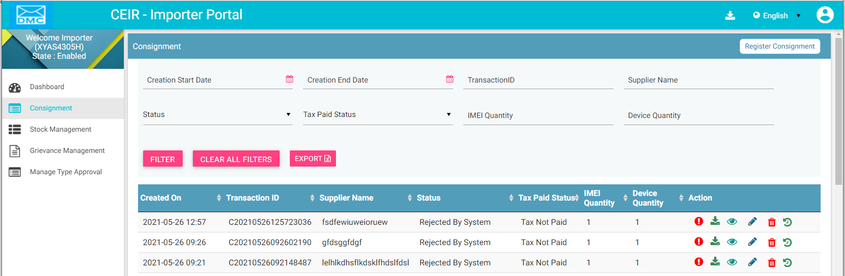

Figure 14: Consignment

**Total IMEIs waiting for approval**

This box displays the total number of devices (IMEIs in the consignments) waiting to be cleared by the customs.

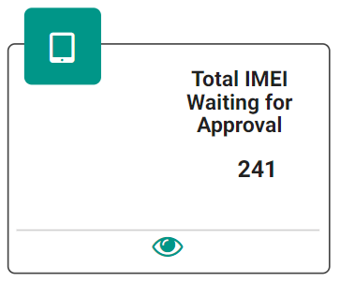

Click  (**View)** to access the **Consignment** dashboard. Refer to *Consignment Management* for more information.

**Stock**

The stock box displays the total number stock entries pending approval.

Click  (**View)** to access the **Stock Management** dashboard. Refer to *Stock Management* for more information.

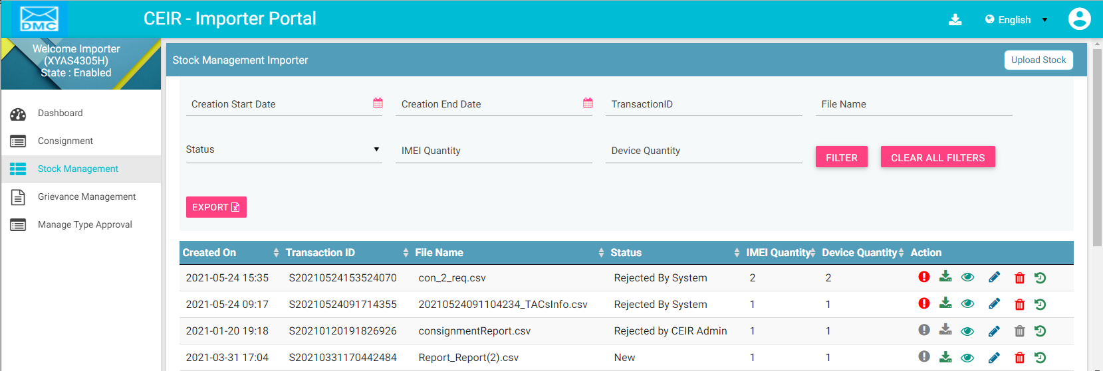

Figure 15: Stock Management

**Total Devices Waiting for Upload**

The box displays the total number of devices (IMEIs in stock) pending for upload.

Click  (**View)** to access the **Stock Management** dashboard. Refer to *Stock Management* for more information.

**Grievances**

The box displays the total number of grievances that are open.

Click  **(View)** to access the **Grievance Management** dashboard. Refer to *Grievance Management* for more information.

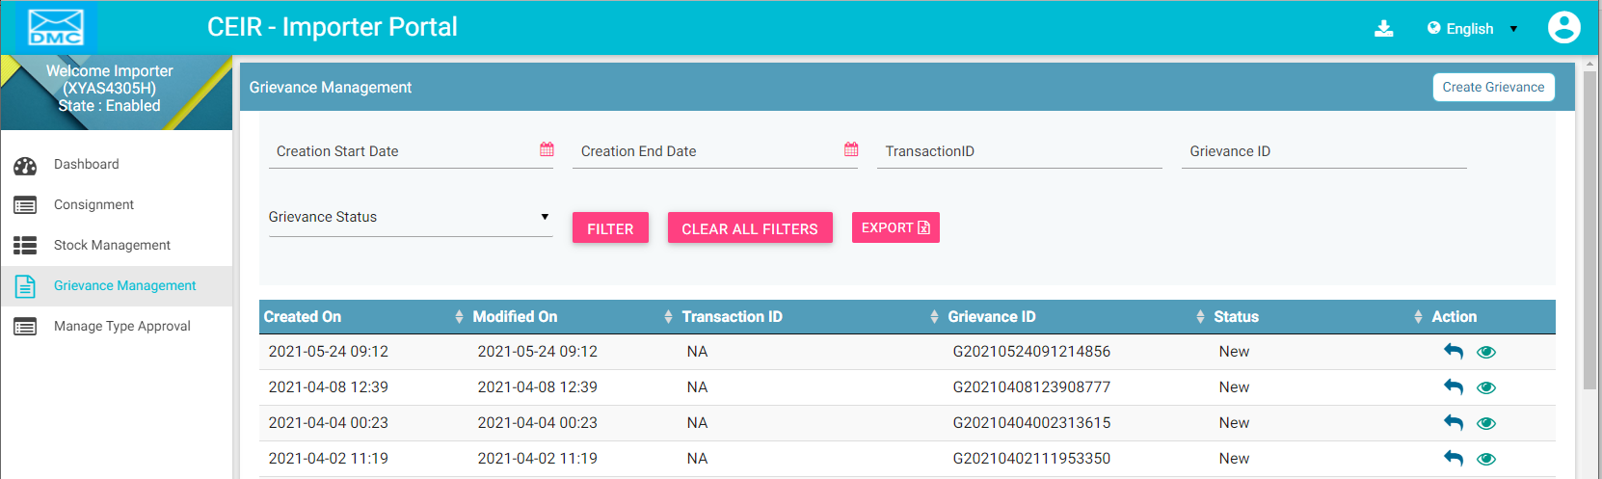

Figure 16: Grievance Management

**Type Approved**

The box displays the total number of type approval requests that are pending for approval.

*Click*  (**View**) to access the **Manage Type-Approved** dashboard. Refer to *Type Approval Management* for more information.

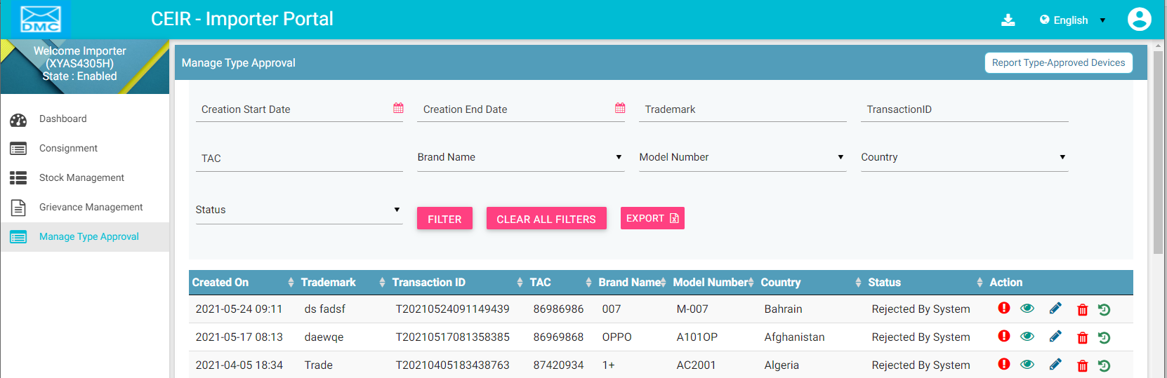

Figure 17: Manage Type-Approved

**Notification Information**

This section displays the most recent notifications. System Admin can configure the number of notifications that are displayed on user dashboard.

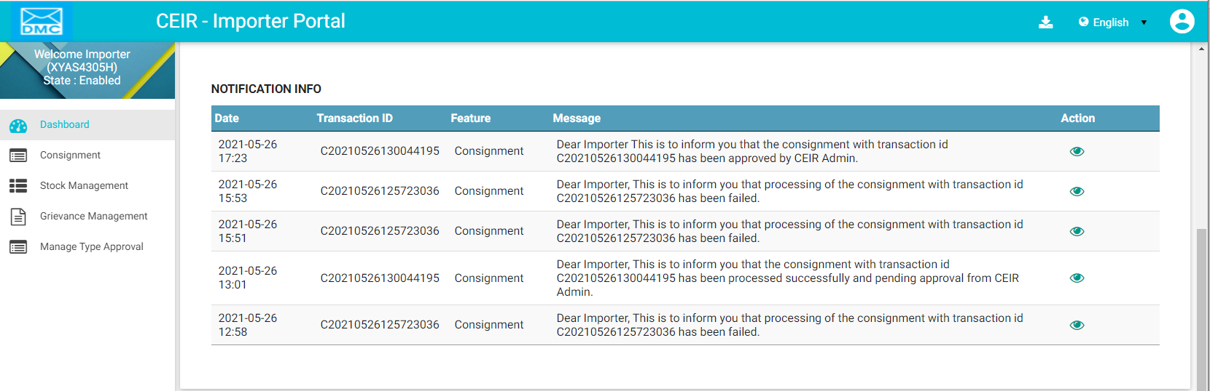

Figure 18: Home Page

Notifications are of two types.

1. Notifications that provide only information. For example, a notification informing the importer about the account status is an information only notification because it requires no action. The **View** icon () is disabled in such notifications.



1. Notifications that require some action by the importer. For example, a notification about the consignment approval or rejection by the CEIR Admin or customs requires the importer to take some action such as fix the errors in the consignment. The **View** icon () is enabled in such notifications. Click  (**View)** to access the relevant page of the notification.



The notification panel has the following columns:

* **Date**: Date of sending the notification
* **Transaction ID**: Transaction ID of the consignment or stock or grievance or type approval request for which the notification is sent. If the notification is related to the importer account, the login username is shown instead of any transaction ID.
* **Feature**: This is the name of the feature for which the notification is sent. For example, if the notification is for a consignment, the feature name **Consignment** is shown. If the notification is concerning a stock transaction, the feature name **Stock Management** is shown. The feature name is the one shown in the left panel of the Home page.
* **Message**: This is the message of the notification. An example is shown below.



* **Action**: This shows the **View** icon. It is activated  if the importer can click on it else it is disabled .





## Manage Consignments

Importers purchase consignments from suppliers. After a consignment is ordered, the importer must register the imported consignment in the application.

The flow of information in the consignment lifecycle is as follows:

1. After ordering a consignment from a supplier, the importer registers the consignment and supplier information in the system.
2. The system validates the information.
3. If the system rejects it, the information is available to importers for correction and the above flow is repeated.
4. On successful validation, the CEIR Admin reviews the information for completeness and accuracy.
5. If the CEIR Admin rejects it, the information is available to importers for correction and the above flow is repeated.
6. After it is approved by the CEIR Admin, it is shared with the customs for clearance.
7. If the customs reject the consignment, the information is available to importers for correction and the above flow is repeated.
8. After the physical consignment arrives at the customs premises, the importer goes to the customs office and pays the required tax. Customs clear the consignment and hands it over to the importer. The consignment is now ready for sale in the market.

Note: In case the importer raises a consignment, with TAC information which is not approved with TAC authority using Manage Type approval Feature, the custom officer will approve the consignment only after validating a valid TAC certificate for the same.

To register consignments in the application:

1. Select the **Consignment** menu in the left panel of the application Home page.  
   

Figure 19: Home Page

The **Consignment** dashboard appears.

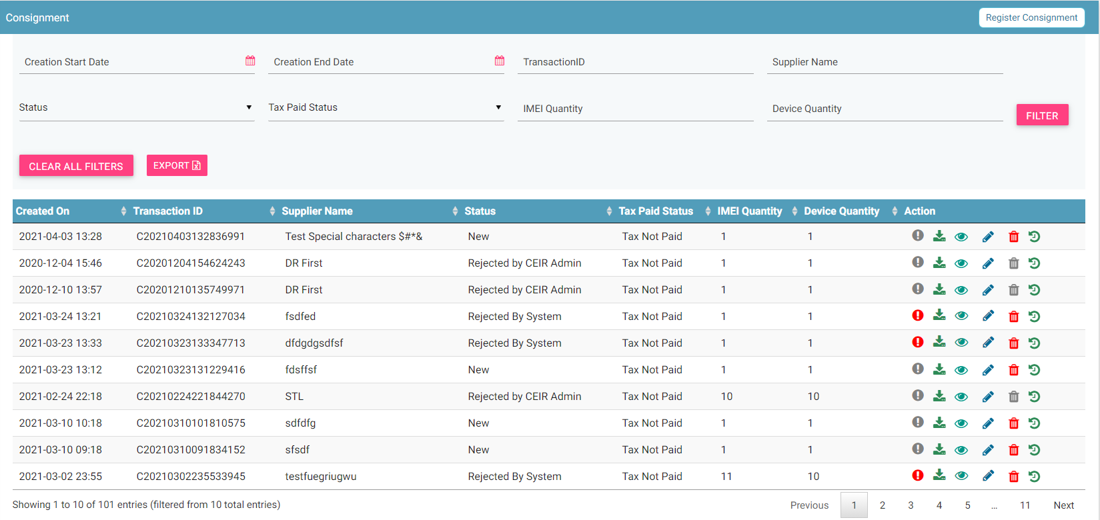

Figure 20: Consignment

1. Click **Register** **Consignment** seen on the top right corner of the page. The **Register Consignment** page appears.

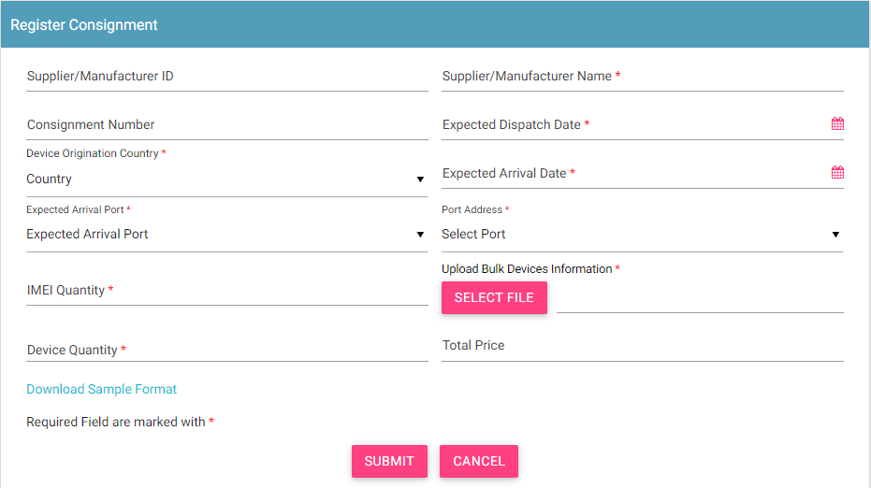

Figure 21: Register Consignment

1. Enter the following information:
   1. **Supplier/Manufacturer ID**: Enter the supplier or manufacturer ID from whom the importer has purchased the consignment.
   2. **\*Supplier/Manufacturer Name**: Enter the supplier’s name.
   3. **Consignment Number**: Enter the consignment number.
   4. **\*Expected Dispatch Date**: Select the date by when the consignment would be dispatched by the supplier. A calendar is shown. Select the date from the calendar.
   5. **\*Device Origination Country**: Select the country from where the consignment is being sent. A list of countries is shown. Select the country from the list.
   6. **\*Expected Arrival Date**: Select the date by when the consignment would reach the customs premises. A calendar is displayed. Select the date from the calendar.
   7. **\*IMEI Quantity**: Enter the number of IMEIs in the consignment.
   8. **\*Device Quantity**: Enter the number of devices in the consignment
   9. **Total Price**: Enter the total price of the consignment.
   10. **Currency**: Select the currency from the list. This field appears only when you enter **Total Price**.
   11. **\*Expected Arrival Port**: Specify whether the consignment is being sent by air, land, or sea.
   12. **\*Port Address**: Enter the port address.
   13. **\*Upload Bulk Devices Information**: Enter the consignment details in a file. This is a **.csv** file with defined column names. You need to enter device information under each column.
   14. Download the file format. Click **Download Sample** **Format**.

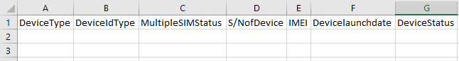

The file has the following columns:

* + **\*Device type**: The device can be a handheld phone, mobile phone, feature phone, smart phone, Vehicle, Portable (include PDA), Module, Dongle, WLAN router, modem, connected computer, tablet, e- Book.
  + **\*Device ID type**: Type can be IMEI
  + **\*Multiple SIM Status**: Number of SIMs the device supports (1-4)
  + **\*S/N of Device**: Device serial number
  + **\*IMEI**: Value of IMEI
  + **Device launch date**: Launch date or manufacturing date of the device (in the format, DDMMYYYY).
  + **Device status**: Whether the device is new or used (New/Used)
  1. Enter the required information in each column for each item.

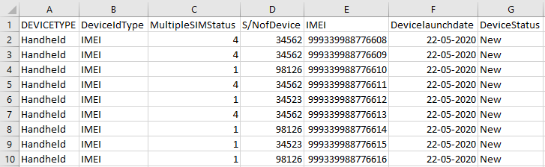

* 1. After entering all the information, save the file.
  2. Click **SELECT FILE** to upload the file to the application.

1. Click **SUBMIT**. A unique transaction ID is assigned to the uploaded consignment.

The uploaded consignment appears in the top row on the dashboard.

For each consignment uploaded, the dashboard displays the following information:

| **Column** | **Description** |
| --- | --- |
| Creation Date | Date of registering the consignment in the system. |
| Transaction ID | This is an automatically generated ID that is assigned to the consignment when it is registered. |
| Supplier Name | This is the name of the supplier of the consignment. |
| Status | The registered consignment goes through different status modes.   * New: When a consignment is registered, its status is **New**. * Processing: The consignment is processed by the application and validated. * Rejected by System: If the consignment does not have valid information, an error file is generated. The importer can view the file and fix the errors in the consignment. * Pending Approval from CEIR Authority: After the consignment is validated by the system internally, the consignment is available for review by the CEIR Admin. * Rejected by CEIR Admin: The CEIR Admin reviews the details and rejects the consignment if there is a problem. The importer can view the file and fix the errors in the consignment. * Pending Clearance from Customs: After the consignment is approved by the CEIR Admin, the consignment is available for clearance by the customs. * Approved: When the customs clear the consignment, the status changes to **Approved**. * Rejected by Customs: When the customs do not clear the consignment, the status changes to **Rejected**. The importer can view the file and fix the errors in the consignment. * Withdrawn by importer: The importer can withdraw the consignment if there is a problem with the consignment. This can be done only when the status is **New** or **Rejected by System**. * Withdrawn by CEIR: The CEIR Admin can withdraw the consignment. |
| Tax Paid Status | Indicates whether tax has been paid or not. The status changes to **Tax Paid** when the customs clear the consignment. |
| IMEI Quantity | This is the number of IMEIs in the consignment. |
| Device Quantity | This is the number of unique devices in the consignment |
| Action | This displays different actions that can be performed on the consignment.   * Error : This is seen when there is an error file generated because of invalid consignment information entered in the application. Click on it to download the error file. * Download A circuit board    Description automatically generated: This is used to take a dump of the consignment file that is uploaded to the system. * View : This is used to view the consignment. * Edit A close up of a logo    Description automatically generated: This is used to modify the consignment. * Delete : This is used to delete the consignment. * History : This is used to view the transaction history of the consignment. |

## Edit Consignments

Importers can modify the uploaded consignment. This is done when there is an error reported in the consignment.

To modify a consignment:

1. Click **Edit (**A close up of a logo

   Description automatically generated**)**  against the consignment to modified.



Figure 22: Consignment

The **Edit Consignment** page appears.

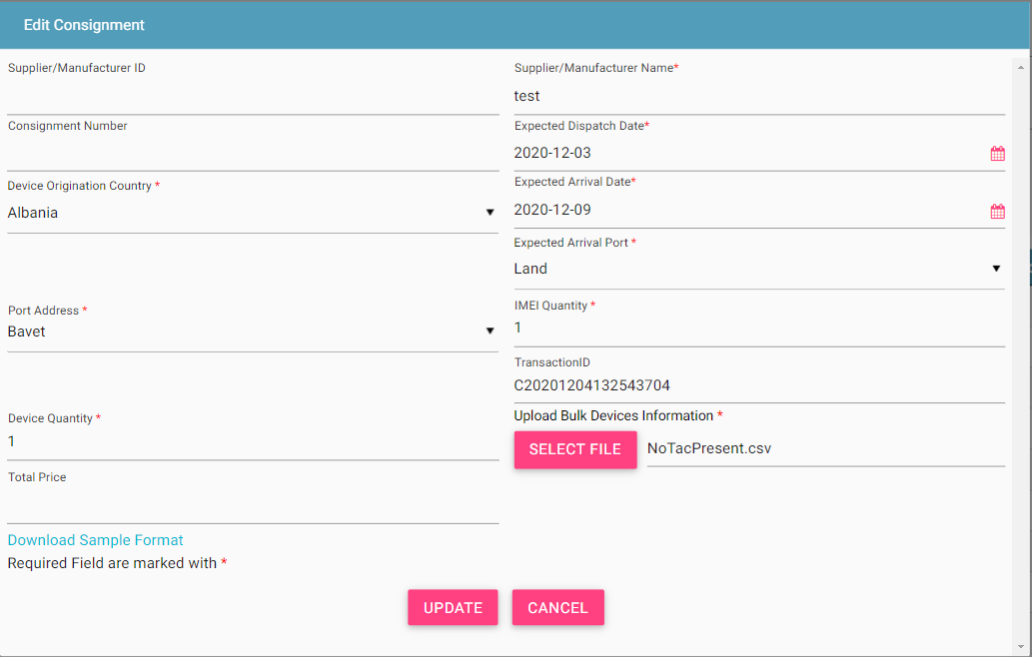

Figure 23: Edit Consignment

1. Make the required changes
2. Click **UPDATE**.

The status of the consignment changes to **New** and is submitted for reprocessing.

## Filter Consignments

Importers can view specific consignments after selecting the required filters. For example, importers can view consignments that are pending clearance by customs or consignments that have been rejected by the CEIR Admin.

To view specific consignments based on filters:



Figure 24: Consignment

1. Enter data in one or more of the listed fields:

* **Start** **Date** and **End** **Date**: This refers to the registering date of consignments in the system.
* **Transaction ID**: Each consignment is assigned a unique transaction ID. Importers can view a specific consignment by entering its transaction ID.
* **Supplier Name:** Importers can view a specific consignment by entering supplier name.
* **Consignment Status**: This refers to the status of the consignment such as New, Processing, and other status modes.
* **Tax Paid Status**: This indicates whether tax is paid for the consignment. Importers can view selective consignments.
* **IMEI Quantity**: This refers to the total number of IMEI count in the consignment uploaded.
* **Device Quantity**: This refers to the total device count in the consignment uploaded.

1. Click **FILTER**.

The consignments that match the filter values are shown in the dashboard.

Figure 25: Consignment

The user can clear all filters using the “**Clear All Filters**” button. This will reset all the filter values applied on the page and the data table is refreshed.

## Sorting Consignments

By default, all records displayed are sorted based on modified date. User can sort the records as per his convenience by clicking the arrow button on header in the table displayed.

On first click, the records are sorted in ascending order. When user clicks the arrow buttons again, records are sorted in descending order.

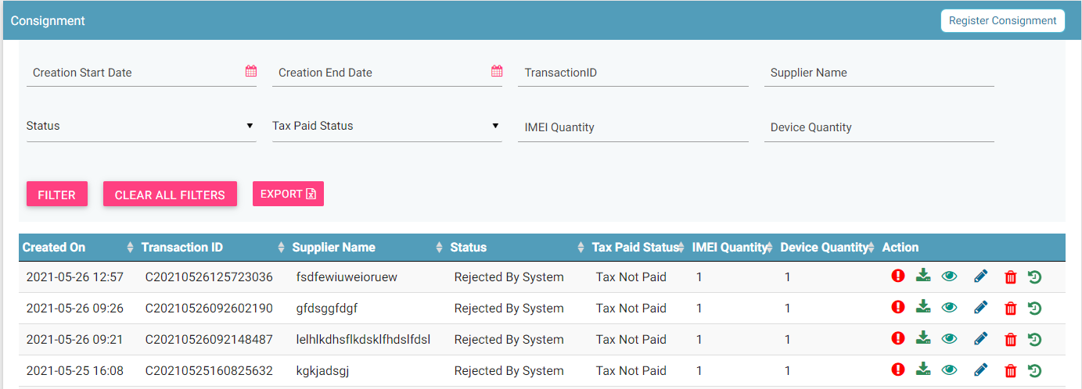

Figure 26: Sort Consignment

## Export Consignments

Importers can download all the uploaded consignments in a **.csv** file. This is done using an export utility.

To export the uploaded consignments:

1. Click **Export** 

Figure 27: Export Consignment

The following page appears.

Figure 28: Open or Save Exported Consignment File

1. Click **Open with** to view the **.csv** as an Excel file.

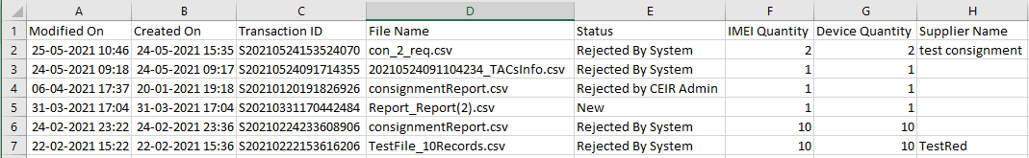

Figure 29: Exported Consignments

Filtered data can also be exported. To do this, filter specific data by defining specific filter values. Refer to *Filter Consignments* for information and then use the export feature to export the filtered data.

## Stock Management

After the importer pays tax for the consignment, stock is made available for sale in the market. To make stock available for sale stock is uploaded to the system. Only distributors and retailers can upload stock.

There are exceptions to the rule. There are two situations when importers can also upload stock.

* When the importer is also a distributer and/or retailer.
* There is a defined grace period in the system during which importers with old stock can upload their stock. After the grace period is over, the stock upload option is no longer available to the importers. The importers can then only view the uploaded stock.

To upload stock:

1. Select **Stock Management** in the left panel.



Figure 30: Home Page

The following page appears. The importer is required to select a role to proceed. The roles shown here depend on the roles selected during registration. If the importer has selected only the importer role during registration, this page does not appear.

Figure 31: Role Type

1. Select the role type (Retailer, Importer, Distributor). Based on the type of role selected, the **Stock Management** page appears.

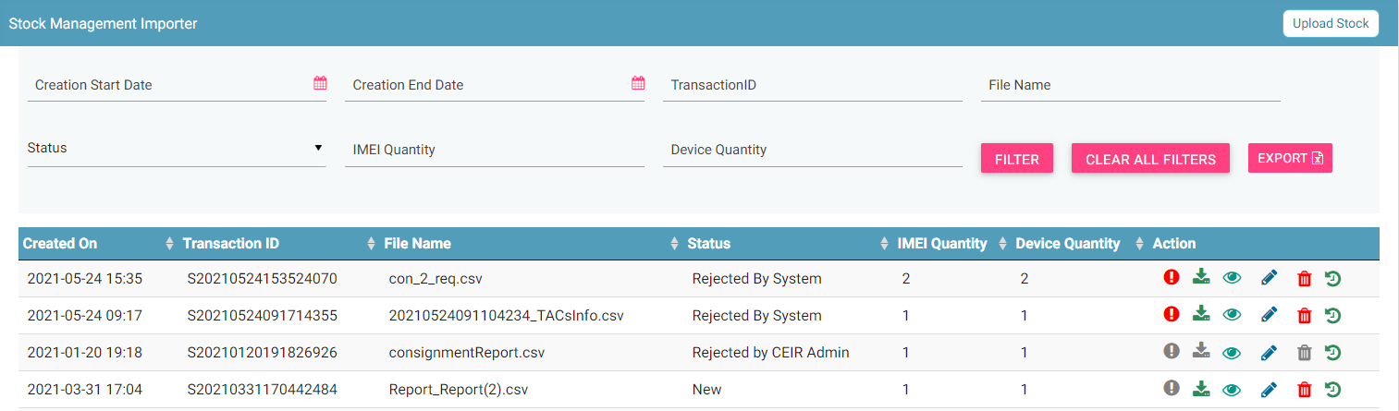

Figure 32: Stock Management

1. Click **Upload Stock**.

The **Upload Stock** page appears.

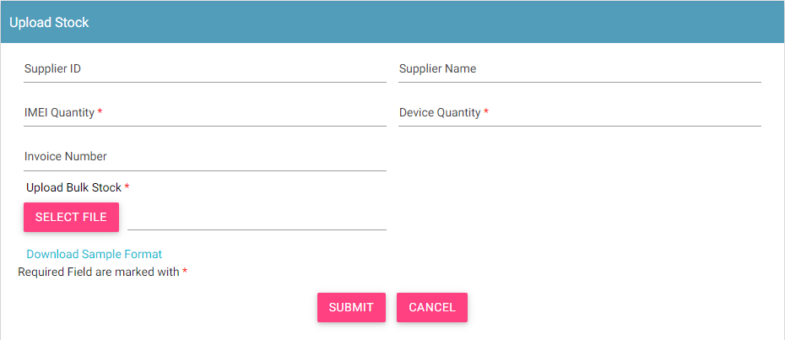

Figure 33: Upload Stock

1. Enter the following information:
   1. **Supplier ID**: Enter the supplier ID.
   2. **\*Supplier Name**: Enter the supplier’s name.
   3. **\*IMEI Quantity**: Enter the total quantity of IMEIs.
   4. **\*Device Quantity**: Enter the total quantity of devices
   5. **Invoice**: Enter the invoice number.
   6. **\*Upload Bulk Stock**: Enter the IMEI details in a file. This is a **.csv** file with defined column names. You need to enter device information in this file. First, download the file format, if required.
   7. Click **Download Sample** **Format**.



The file has the following columns:

* + **\*Device type**: The device can be a handheld phone, mobile phone, feature phone, smart phone, Vehicle, Portable (include PDA), Module, Dongle, WLAN router, modem, connected computer, tablet, e- Book.
  + **\*Device ID type**: Type can be IMEI (International Mobile Equipment Identity)
  + **\*Multiple SIM Status**: Number of SIMs the device supports (1/2/3/4).
  + **\*S/N of** **Device**: Device serial number
  + **\*IMEI**: Value of IMEI
  + **Device launch** **date**: Launch date or manufacture date of the device (in the format, DDMMYYYY).
  + **Device status**: Whether the device is new or used (New/Used)
  1. Enter the required information in each column for each device.



* 1. After you enter the device details, save the file.
  2. Click **SELECT FILE** to upload the file with all the details.

1. Click **SUBMIT**. A unique transaction ID is assigned to the uploaded stock.

The uploaded stock appears on top of the **Stock Management** page.

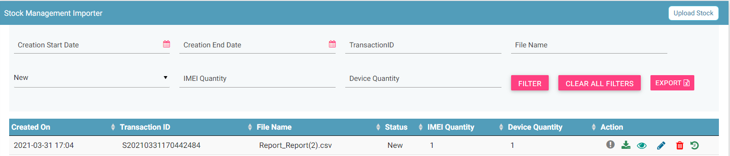

Figure 34: Stock Management

For each stock uploaded, the following columns are seen on the **Stock Management** page.

| **Column** | **Description** |
| --- | --- |
| Date | Date of uploading the stock in the system. |
| Transaction ID | This is an automatically generated ID that helps in identifying and tracking stock. |
| Supplier Name | This is the name of the supplier of the stock. |
| File Name | Name of the stock file. |
| Stock Status | The uploaded stock goes through different status modes.   * New: When the stock is uploaded, its status is **New**. * Processing: The stock is processed and validated. The status changes to **Processing**. * Rejected by System If the stock does not have valid information, an error file is generated. The importer can view the file and fix the errors in the consignment. * Approval Pending by CEIR Admin: The uploaded stock is available for review by the CEIR Admin. * Approved by CEIR Admin: The stock is approved by the CEIR Admin. * Rejected by CEIR Admin: The CEIR Admin reviews the details and rejects the stock if there is a problem. * Withdrawn by User: The user withdraws stock if there is any problem. * Withdrawn by CEIR Admin: The CEIR Admin can withdraw stock. |
| IMEI Quantity | This is the number of IMEIs in the stock. |
| Device Quantity | This is the number of unique devices |
| Action | This displays different actions that can be performed on the stock.   * Error : This is seen when there is an error file generated because of invalid information. Click on it to view the error file. * Download A circuit board    Description automatically generated: This is used to take a dump of the stock that is uploaded to the system. * View : This is used to view the stock details. * Edit A close up of a logo    Description automatically generated: This is used to modify the stock details. * Delete : This is used to delete the uploaded stock. * History : This is used to view the transaction history of the stock. |

## Edit Stock

Importers can modify the uploaded stock.

To edit stock:

1. Click **Edit (A close up of a logo

   Description automatically generated)** against the stock entry to be modified.

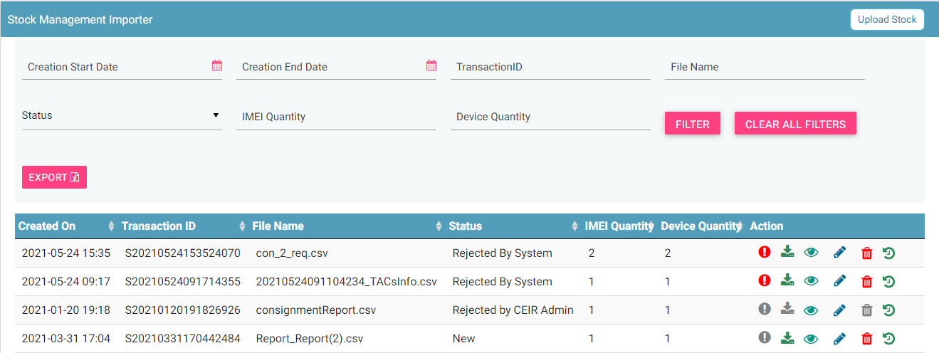

Figure 35: Stock Management

The **Edit Stock** page appears.

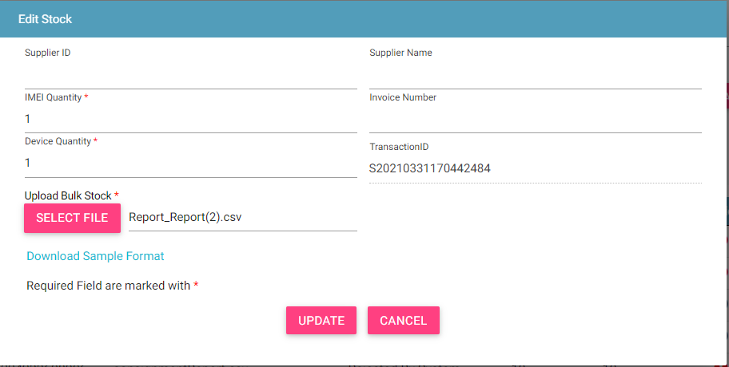

Figure 36: Edit Stock

1. Make the required changes.
2. Click **UPDATE**.

## Filter Stock

Importers can view selective stock by defining specific values in the listed fields. For example, importers can view all the stock that is in the processing status or the stock that is pending for approval by the CEIR Admin.

To view specific stock:



Figure 37: Stock Management

1. Enter the required value in one or more of the listed fields:

* **Start Date and End Date**: This refers to the period of uploading stock.
* **Transaction ID**: Each stock file is assigned a unique ID. Importers can view specific stock by entering its stock transaction ID.
* **File Name**: This refers to the input file name.
* **Status**: This refers to the status of the stock such as New, Processing, Rejected by System, etc. Select the status of the stock to be displayed.
* **IMEI Quantity**: This refers to the IMEI quantity
* **Device Quantity**: This refers to the device quantity.

1. Click **FILTER**.

The stock that matches the specified values are shown in the dashboard.

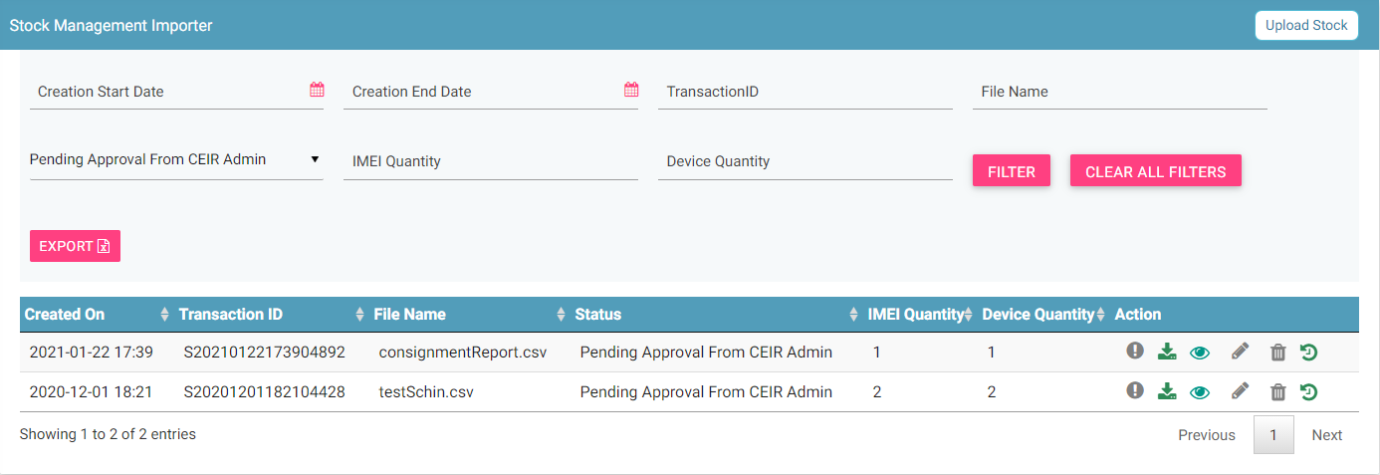

Figure 38: Stock Management

The user can clear all filters using the “**Clear All Filters**” button. This will reset all the filter values applied on the page and the data table will be refreshed.

## Sorting Stock

By default, all records displayed are sorted based on modified date. User can sort the records by clicking the arrow button on header in the table displayed.

On first click, the records are sorted in ascending order. When user clicks the arrow buttons again, records are sorted in descending order.

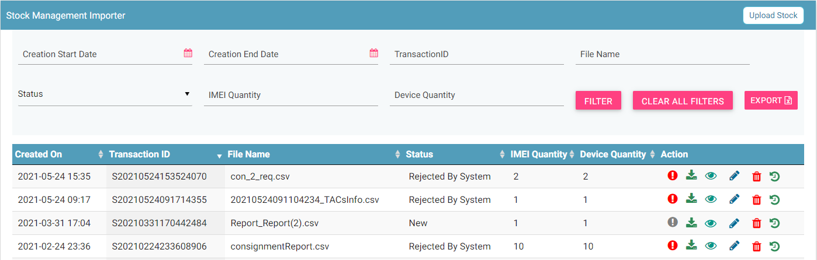

Figure 39: Stock Management

## Export Stock

Importers can download all the uploaded stock data in a **.csv** file. This is done using an export utility.

To export the uploaded stock:

1. Click **Export** (seen on the top right corner of the **Stock Management** page).



Figure 40: Stock Management

The following page appears.

Figure 41: Open or Save Exported Stock File

1. Click **Open with** to view the file. The file opens as an Excel file.

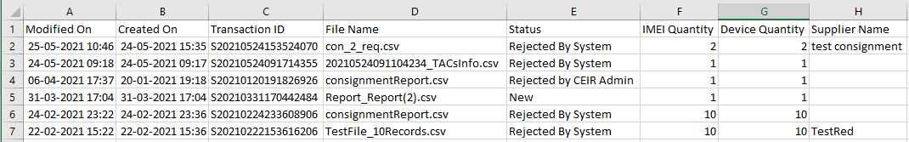

Figure 42: Exported Stock

Filtered stock can also be exported. To do this, filter stock based on specific filter values. Refer to *Filter Stock* for information and then export the filtered data.

## Grievance Management

Importers can register complaints or grievances when there is a problem in the portal. For example, there could be situations when the registration feature is not working or there could be a problem in consignment upload.

When an importer raises a grievance, the grievance goes through the following stages:

1. A notification is sent to the CEIR Admin. The notification appears on the CEIR Admin portal. A mail is also sent to the registered mail of the CEIR Admin.
2. The CEIR Admin responds to the grievance. A response notification is sent to on the importer portal, and the importer’s registered mail ID.
3. Steps 1 to 2 are repeated until the grievance is closed. The CEIR Admin closes the grievance.

There are situations when the grievance is automatically closed. A grievance is automatically closed when the status of the grievance changes to **Pending with User**, but there is no response from the importer for a specified period.

To raise a grievance

1. Select **Grievance Management** in the left panel.



Figure 43: Home Page

1. The **Grievance Management** page appears. Click **Create Grievance**.

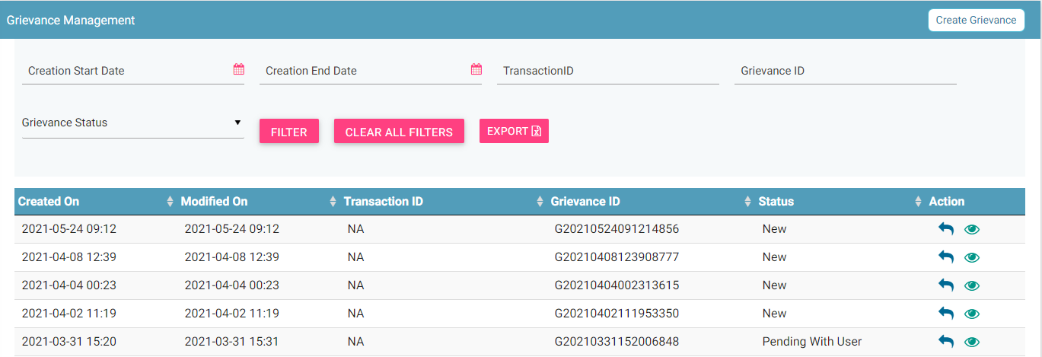

Figure 44: Grievance Management

The **Create Grievance** page appears.

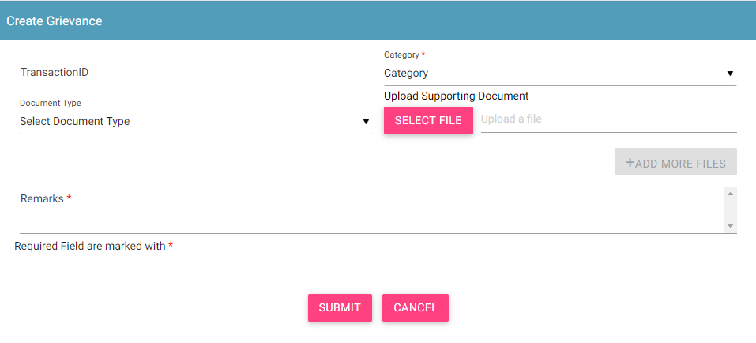

Figure 45: Create Grievance

1. Enter the following information:
   1. **Transaction ID**: Enter the transaction ID of the consignment if the grievance is related to a consignment or the transaction ID of the stock if the grievance is related to stock.
   2. **\*Category**: Select the category of the grievance. The options are:

* Report Related: Unable to generate a report.
* Consignment Related: Problem with registering consignment etc.
* Stock Related: Problem with uploading stock etc.
* Other: Problem with any other aspect of the application
* Registration Related: Problem with registering information in the application.
  1. **\*Remarks:** Enter information about the grievance raised. This helps the Admin to understand the problem in detail.
  2. **Document Type:** Select the type of identification or another document that is to be uploaded. The options are:
* Passport
* Visa
* NID (National ID)
* Photo
* Other
  1. **Upload Supporting Document:** Click **Select File** to upload the document selected in **Document Type**.
  2. To upload more documents,click **+Add More Files.**

This adds two more fields: **Document Type** and **Select File**.

1. Click **SUBMIT**.

A grievance ID is generated and assigned to the registered grievance. The registered grievance appears on top of the dashboard.



Figure 46: Grievance Management

For each grievance added, the following information is displayed on the page.

| **Column** | **Description** |
| --- | --- |
| Raised Date | Date of raising a grievance. |
| Last Update Date | The date when the grievance was modified. |
| Transaction ID | The transaction ID of stock or consignment for which a grievance was raised. |
| Grievance ID | This is the ID that is automatically assigned to the grievance. |
| Grievance Status | The uploaded grievance goes through different status modes.   * New: When a grievance is raised. * Pending with CEIR Admin: When a response is awaited from the CEIR Admin. * Pending with User: When a response is awaited from the importer. * Closed: When the CEIR Admin closes the grievance. |
| Action | This displays different actions that can be performed on a grievance.   * Reply : This is used to respond to the grievance. The response is given by the CEIR Admin or importer. The exchange of responses is done until the grievance is closed. * View A close up of a logo    Description automatically generated: This is used to view the grievance response history. The importer can see all the responses exchanged for any grievance. |

## Filter Grievances

The importer can view selective grievances depending on specific filter values. For example, the importer can view only those grievances that are pending with the CEIR Admin. Similarly, one can view only those grievances that are closed.

To filter grievances:



Figure 47: Filter Grievances

1. Specify the required value in one or more of the fields listed:

* **Start Date** and **End Date**: Period of raising grievances.
* **Transaction ID**: This is the transaction ID of the stock or consignment.
* **Grievance ID**: This is the ID assigned to the grievance.
* **Grievance Status**: The status can be:
  + New
  + Pending with CEIR Admin
  + Pending with User
  + Closed

1. Click **Filter**.

The filtered grievances are shown on the page.



Figure 48: Filtered Grievances

The user can clear all filters using the “**Clear All Filters**” button. This will reset all the filter values applied on the page and the data table will be refreshed.

## Sorting Grievance

By default, all records displayed are sorted based on modified date. User can sort the records as per his convenience by clicking the arrow button on header in the table displayed.

On first click, the records are sorted in ascending order. When user clicks the arrow buttons again, records are sorted in descending order.

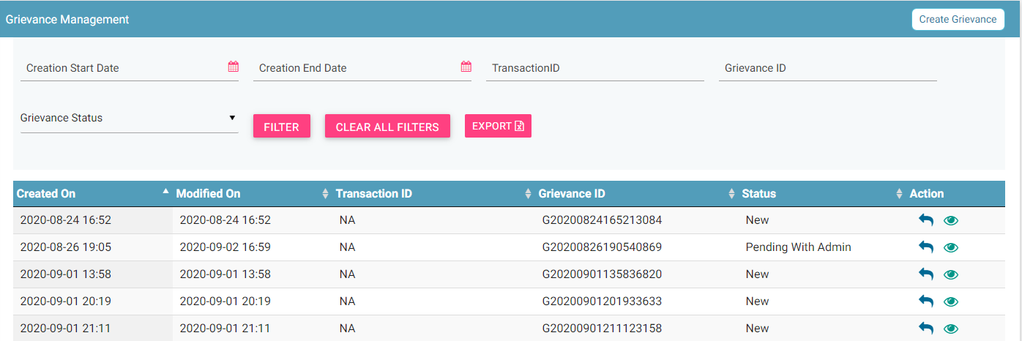 Figure 49: Grievance Management

## Export Grievances

All the uploaded grievances can be downloaded in a **.csv** file. This is done using an export utility.

To export the grievances:

1. Click **Export** (seen on the top right corner of the **Grievance Management** page).

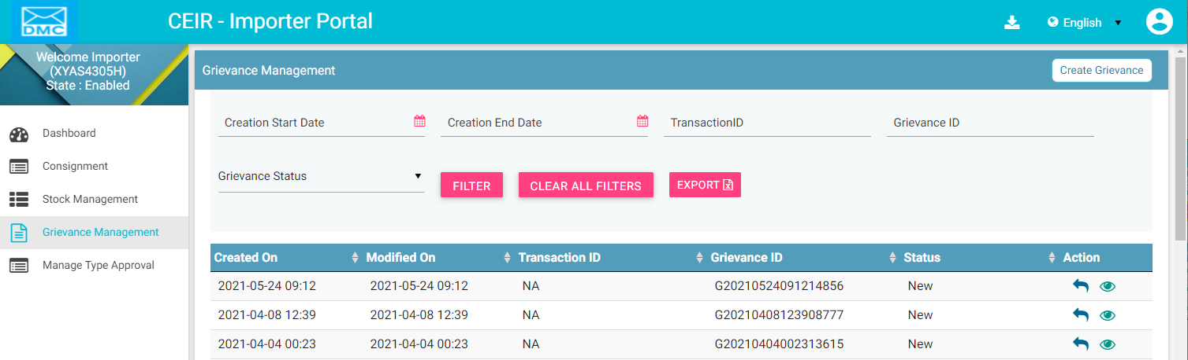

Figure 50: Grievance Management

The following page appears.

Figure 51: Open or Save Exported Grievance File

1. Click **Open with** to view the file.

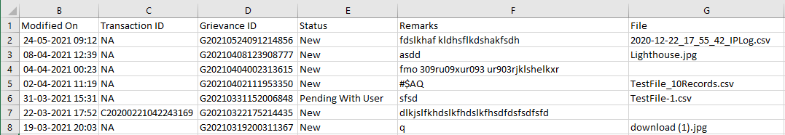

Figure 52: Exported Grievances

Instead of exporting all the grievances, importers can export filtered grievances. First, filter the grievance data based on specific filters (refer to *Filter Grievances*) and then export the filtered grievances using the export utility.

## Type Approval Management

Importers get a TAC (Type Allocation Code) approval certificate from the TRC (Telecommunication Regulator of Cambodia) when purchasing a consignment. The TAC approval certificate is required for each unique TAC.

* TAC refers to the first eight alphanumeric characters of the device IMEI.

Consider a situation in which an importer is purchasing a consignment that has Apple mobile devices: i10 and i9. There would be two TAC approval certificates required, one for the i10s and the other for i9s.

The TAC approval certificate is required for clearance at customs. Therefore, it is mandatory for the importers to upload the certificates before the consignment reaches the customs premises.

The type approval request goes through the following review stages:

* Importer uploads the request details.
* The request is processed and made available to the CEIR Admin.
* The CEIR Admin may approve or reject the request.
* If rejected, the importer can withdraw the request. The entire cycle is then repeated until it is approved.

To upload type approved device details:

1. Select **Manage Type Approval** in the left panel.



Figure 53: Home Page

The **Manage Type-Approved** dashboard appears.

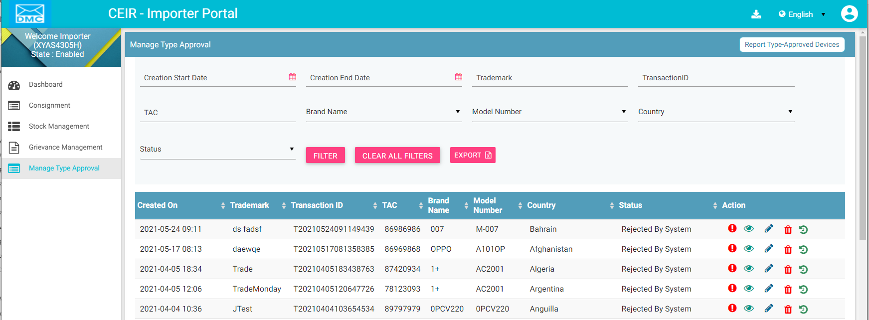

Figure 54: Manage Type-Approved

1. Click **Report Type-Approved Devices** (seen on the top right corner of the page). The **Type-Approved Devices** page appears.

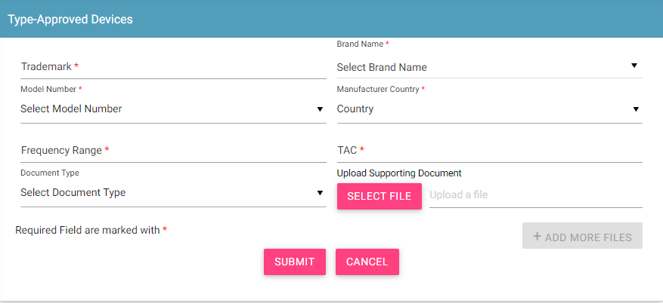

Figure 55: Type-Approved Devices

1. Enter the following information:
   1. **\*Trademark**: Enter the trademark of the product.
   2. **\*Brand Name**: Select the brand name from the list.
   3. **\*Model Number**: Select the model number of the product.
   4. **\*Country**: Select the country from where the device is imported.
   5. **\*Frequency Range**: Enter the frequency range supported by the device.
   6. **\*TAC**: Enter the code of the device.
   7. **Document Type**: Select the type of document being uploaded. Importers are required to upload three documents:
      * Technical Specifications: This document has all the technical specifications of the device.
      * Performance Report: This document has the performance details of the device.
      * TAC Approval Certificate: This is the approval certificate issued by the supplier.
   8. **Upload Supporting Document**: Click **Select File** to upload the document.
   9. Click **+Add More Files** to upload more documents. This adds another set of **Document Type** and **Upload Supporting Document**.
2. Click **Submit**.

The type approval request is added, and a transaction ID is assigned to it.

The details appear on top of the **Manage Type- approved** page.

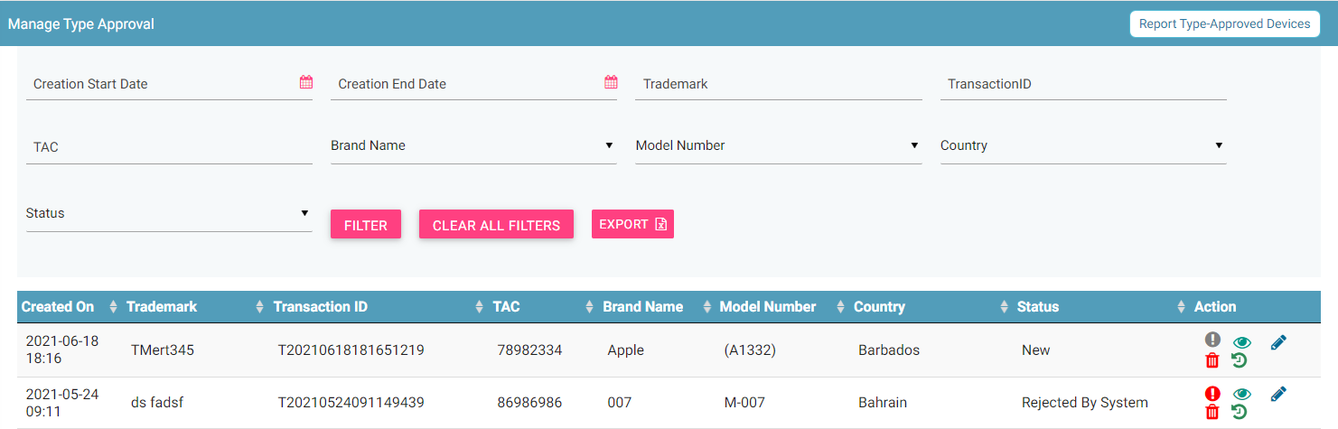

Figure 56: Manage Type-Approved

The following columns are seen on the page.

| **Column** | **Description** |
| --- | --- |
| Creation On | Date of adding type approval request. |
| Trademark | Trademark name |
| Transaction ID | Transaction ID assigned to the request. |
| TAC | Type allocation code of the device. |
| Brand Name | Brand Name of the device. |
| Model Number | Model number of the device. |
| Country | Country from where the device has been imported. |
| Status | * New: This is the status assigned to the type approval request. * Processing: The request is processed internally. * Rejected by System: The request is rejected by the system if there is an error in the type approval request. * Approval Pending by CEIR Admin: After the processing is done, the type approval request sent for approval to the CEIR Admin. * Approved by CEIR Admin: The CEIR Admin approves the request. * Rejected by CEIR Admin: The CEIR Admin rejects the request. * Withdrawn by CEIR Admin: The CEIR Admin can withdraw the type approval request. * Withdrawn by User: The importer can withdraw the type approval request. |
| Action | This displays different actions that can be performed on the type approval request.   * Error : This is seen when there is an error file generated because of invalid information. Click on it to view the error file. * View A close up of a logo    Description automatically generated: This is used to view the type approval request. * Edit A close up of a logo    Description automatically generated: This is used to change the type approval request. * Delete : This is used to delete the type approval request. * History : This is used to view the transaction history of the type approval request. |

## Edit Type Approved Devices

Importers can modify the type approval request details.

To modify type approval request:

1. Click **Edit (A close up of a logo

   Description automatically generated)** against the entry to be modified.

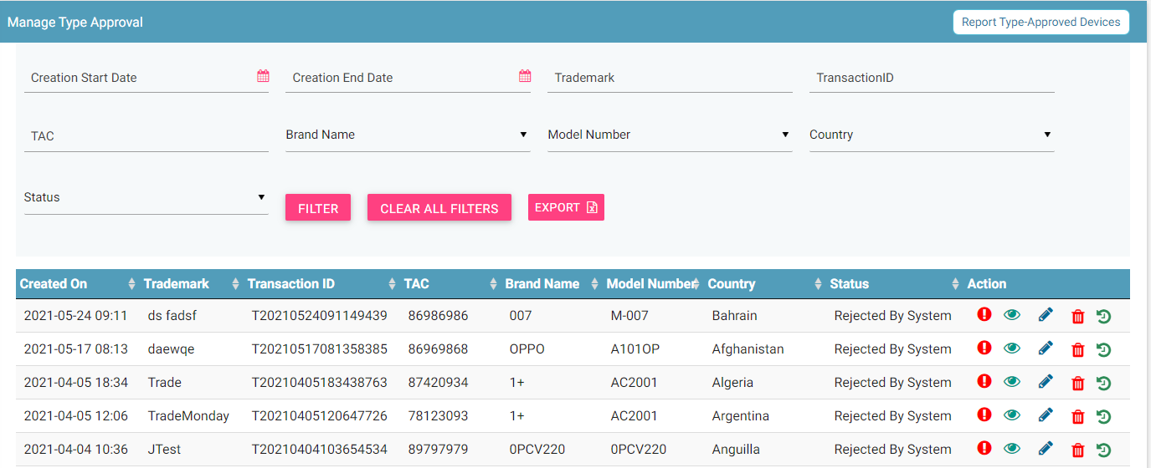

Figure 57: Manage Type-Approved

The **Update Report Type-Approve Devices** page appears.

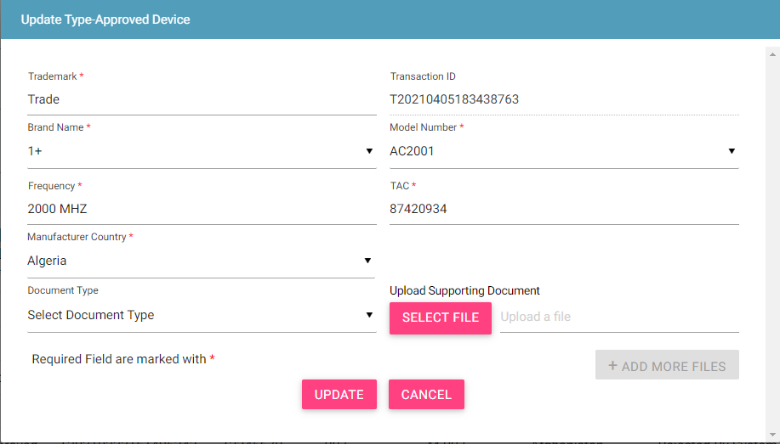

Figure 58: Update Report Type-Approve Devices

1. Make the required changes.
2. Click **UPDATE**.

## Filter Type Approval Requests

Importers can view specific type approval requests after defining specific values in the listed fields. For example, the importer can view a device of a given TAC or a record if its transaction ID is known.

To view specific type approval requests:

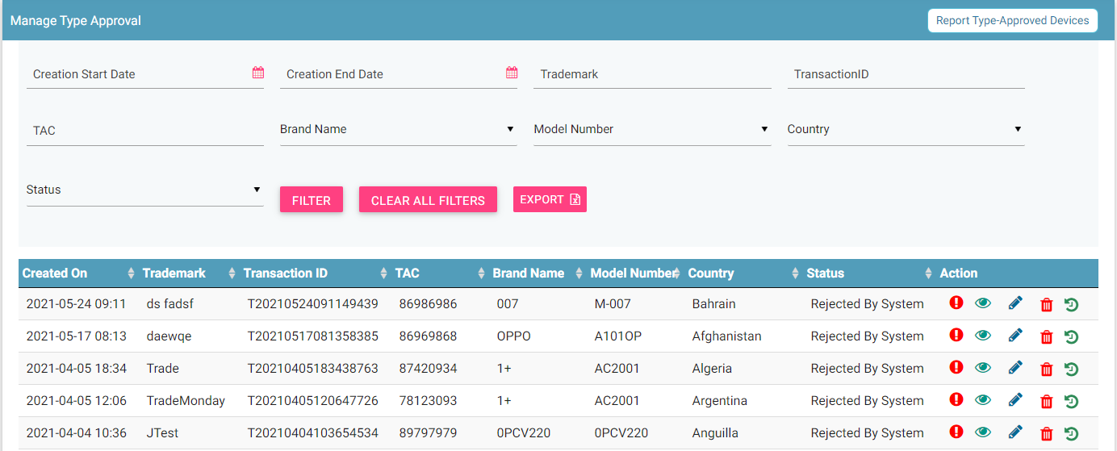

` 12

Figure 59: Filter Type Approval Requests

1. Enter the required value in one or more of the listed fields:

* **Start Date and End Date**: This refers to the period of adding type requests in the system.
* **Trademark**: The trademark of the product.
* **Transaction ID**: Each type approval request is assigned a unique transaction ID.
* **TAC**: This is the TAC assigned to the device.
* **Brand Name**: Brand name of the device.
* **Model Number**: Model number of the device.
* **Country**: Country from where device is imported.
* **Status**: Status of the type approval request.

1. Click **FILTER**.

The type approval requests that match the specified values are shown in the dashboard.



Figure 60: Filtered Type Approval Requests

The user can clear all filters using the “**Clear All Filters**” button. This will reset all the filter values applied on the page and the data table will be refreshed.

## Sorting Type Approved Requests

By default, all records displayed are sorted based on modified date. User can sort the records as per his convenience by clicking the arrow button on header in the table displayed.

On first click, the records are sorted in ascending order. When user clicks the arrow buttons again, records are sorted in descending order.

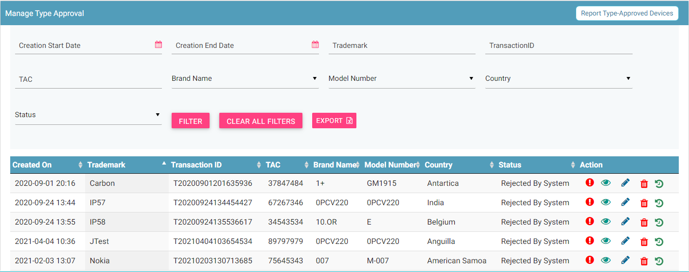

Figure 60: Filtered Type Approval Requests

## Export Type Approved Devices

All the uploaded type approval requests can be downloaded in a **.csv** file. This is done using an export utility.

To export the type approval requests:

1. Click **Export** (seen on the top right corner of the **Manage Type-Approved** page).



Figure 61: Export Type Approval Requests

The following page appears.

Figure 62: Open or Save Exported File

1. Click **Open with** to view the file. The file opens as an Excel file.

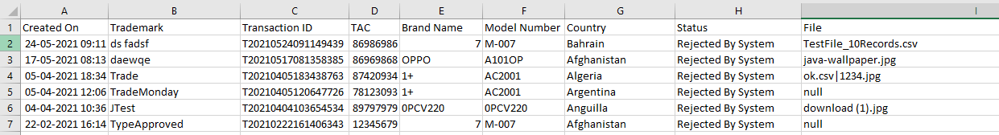

Figure 63: Exported Type Approval Requests

Users can export filtered data as well. To do this, filter the type approval requests and then export the filtered data. Refer to *Filter Type Approval Requests* for information and then export the filtered data.